Movement ecology

Size-dependent tradeoffs in seasonal environments facilitate differential migration

Philip Dermond1,2*, Carlos J. Melián1,2,a, & Jakob Brodersen1,2,a

1Department of Fish Ecology and Evolution, EAWAG Swiss Federal Institute of Aquatic Science and Technology, Centre of Ecology, Evolution and Biogeochemistry, Seestrasse 79, CH-6047 Kastanienbaum, Switzerland

2Institute of Ecology and Evolution, Aquatic Ecology , University of Bern, Baltzerstrasse 6, CH-3012 Bern, Switzerland

*To whom correspondence should be addressed

a Shared last authorship

# Abstract

Seasonal spatio-temporal variation in habitat quality leads to animals migrating between different environments around the world. Whereas mean population timing of migration is often fairly well understood, explanations for variation in migratory timing within populations are often lacking. Condition-dependent tradeoffs may be an understudied mechanism that can explain this differential migration. We introduce a model based on size-specific tradeoffs between migration and growth in seasonal environments . We predict that migratory timing occurs when individuals move from their natal habitat as soon as the ratio predation to growth becomes slightly favorable in the alternative habitat. We compare our model predictions to empirical data on three years of migratory movement from natal to feeding habitat. Both our model and the empirical data show that large individuals, which have a lower predation risk in the natal habitat, move earlier than smaller individuals. Our model also predicts that the observed difference between early and late migrants occur most often at low values of growth differential between the two habitats, suggesting that it is not merely high growth potential but rather the tradeoff between predation and growth that shapes differential migration patterns. These results show tradeoffs in differential migration are needed to understand metapopulation persistence in dynamic landscapes

# Introduction

Migration is a spectacular movement undertaken by hundreds of different taxa across the globe. These fascinating movements take place seasonally and can represent the movement of a large fraction of populations and biomass between ecosystems. A key component to migratory movement is timing. As migrants are often tracking temporary resource peaks (Emmenegger et al. 2014; Stefanescu et al. 2017), early or late migration might have direct consequences for fitness, resulting in missed opportunities for growth or even death (Bauer et al. 2016). However, optimal migration theory suggests that timing is not determined solely by external, environmental factors, but also by individual traits (Chapman et al. 2011b), and individuals in most populations do not migrate at the same time even when tracking the same resources (Cristol et al. 1999; Ketterson and Nolan 1983).

Differential migration, i.e. the variation among individuals from the same population in regards to timing and/or destination of their migration, has been widely studied (Brönmark et al. 2013; Cristol et al. 1999). Many factors affecting migratory timing have been identified (Thorpe et al. 1998). Individual traits like body size can influence physiological abilities or other factors like predation risk, thereby changing the optimal time of departure (Langdon and Thorpe 1985; Powolny et al. 2016). Despite a large body of empirical and theoretical work identifying influential factors, conclusive mechanistic explanations for differential migration are still lacking. As competing hypotheses can often make the same prediction for migratory timing based on the same factors (eg, Catry et al. 2005), the complexity of migratory behavior makes the influence of environmental factors difficult to disentangle.

Many aspects of animal life and behavior are governed by state-specific tradeoffs. Examples are found in diverse fields across the biological sciences, including a multitude of examples in evolution (eg, Fleming and Gross 1990; Hereford 2009; Yoshida et al. 2003; Zera and Harshman 2001) and ecology (Kneitel and Chase 2004; Lima 1998a; Loose and Dawidowicz 1994; Reznick 1983). While tradeoffs can sometimes be circumvented when fitness consequences are severe, they are often unavoidable (Angilletta Jr et al. 2003). Acquisition tradeoff theory (eg, Lima 1998b) suggests that a strategy with large benefits like high resource acquisition and higher growth can be associated with a corresponding cost, such as increased mortality through higher predation (Sih et al. 2004; Werner and Anholt 1993). Such tradeoffs between mortality and growth (i.e., μ/G) have been shown to influence not only time spent foraging, but also ontogenetic habitat shifts (Werner and Hall 1988). Once a partial size refuge from predation has been reached, it is then possible to move from a low risk, low benefit to a high resource, high predation environment (Werner and Hall 1988).

Despite ample evidence that state-specific tradeoffs can influence movement and potentially dispersal, migration research has so far not put much focus on their importance in determining variance in patterns of differential migration (*but note* Brönmark et al. 2008; Hulthén et al. 2015; Pomeroy 2006 *for exceptions*). Instead, physiological factors or barriers are often considered to be of higher importance (Kissner et al. 2003; Kuwada et al. 2016; Nebel 2007), even though they are not always supported by empirical data (eg, Guillemain et al. 2009; Saino et al. 2010). However, a tradeoff between the size- and seasonal-specific changes of growth and predation risk could also change the optimal time of migration for individuals of different sizes. As predators are generally limited in their ability to consume prey that exceeds a certain fraction of their own body size for various reasons (Costa-Pereira et al. 2018), larger prey individuals face lower specific risk in highly productive and predator rich environments. An influence of size on timing has been shown in previous studies of salmonid migration and the possibility of predation as an explanatory factor has been proposed (Dieperink et al. 2002; Gross 1987; Jepsen et al. 2000). However, the tradeoff between growth and predation has to our knowledge never been robustly tested as a main cause, despite the ideal suitability of salmonid migration as a model system for such questions. The existence and magnitude of effect of state-specific tradeoffs remain understudied in general (Alerstam and Hedenström 1998; Myers 1981).

Salmonid migration is remarkable in both its extent and diversity. Individuals from the far majority of salmonid species migrate from a natal to a feeding environment before returning for reproduction (Quinn and Myers 2004). The migratory environment generally offers higher growth rates, providing certain fitness related advantages to early arrivals. Despite such benefits (*sensu the "early bird" hypothesis*, Smallwood and Smallwood 1998), the time spent in natal environments and seasonal timing of migration vary greatly between species and even populations (Elliott 1994; Jonsson and Jonsson 2011a; Quinn 2011; Stearns 2003). Size has been shown time and again to strongly influence migratory timing, with larger individuals generally migrating earlier (Bohlin et al. 1996; Fängstam et al. 1993; Jonsson and Jonsson 2009). With habitat-specific growth and predation risk both being affected by size, a growth-mortality tradeoff could be influencing the timing of migration (Werner and Anholt 1993; Werner and Hall 1988). As work on migratory salmonids is generally performed on anadromous populations, studying the effect of predation as a driver of migratory timing has been difficult due to a physiological barrier likely shaping migratory timing (Elson 1957; Hoar 1976) and leading to predictions similar as those of predation to growth tradeoffs. The study of large freshwater systems with migration between streams and lakes but no physiological barrier could be used to control for this effect.

In this study, we combine empirical data and theory to explore various parameters and their influence on the timing of migration. We introduce a model based on a risk-reward tradeoff between predation and growth. This model describes the conditions under which an individual of a given size will migrate from its natal to its migratory or feeding habitat, accounting for the seasonal temporal development of the ratio of size-specific predation pressure to temperature and size dependent growth. Based on this simple model, individuals should move from one environment to the other when the ratio between predation risk and potential growth shifts towards growth, irrespective of the actual values for these parameters. We compare these model results to three years of empirical data on the migration of several hundred trout from twelve tributary streams to a large Swiss pre-alpine lake, Lake Lucerne. We hypothesize that migratory patterns can be predicted based solely on a risk-reward tradeoff, with no physiological barriers, and that larger fish will move out of streams earlier in freshwater migration. If our model and empirical data bear out these hypotheses, it could suggest migration ecology should focus more on biotic interactions like predation or competition as well as classic physiological barriers such as temperature or salinity.

# Material and Methods

## Study system

We studied timing of juvenile trout migration from twelve tributaries into Lake Lucerne in central Switzerland. Lake Lucerne is a large(113.72 km², max depth 214 m), pre-alpine lake that is dominated by perch (*Perca fluviatilis*) in the littoral and whitefish (*Coregonus spp*) in the pelagic. The piscivore community is dominated by size-structured populations of large bodied perch and pike (*Esox lucius*). The latter attain sizes exceeding 100 cm in length, exposing all juvenile trout to some degree of predation risk. Lake-migratory trout can also reach sizes of over 90cm, with most spawning trout ranging between 40 and 50 cm in length.

A large number of trout-dominated streams with highly diverse temperature and flow regimes feed this lake, and extensive adfluvial migrations are known in the system (Rippmann 1987). Earlier work has shown trout populations in some of these streams to be at least partially reproductively isolated, with significant FSTs between many of them (Dermond *2014*), likely due to natal stream homing of migrants and philopatry of resident individuals.

## Model

We predicted differential size-specific time of migration in a seasonally changing environment by accounting for the ratio of size-specific predation pressure to growth, which is also temperature and size-dependent. We partitioned size-specific predation pressure in the lake, *L*, and in the stream, *S*, in two components: *αL* (*αS*), and *PLmax* (*PSmax*), where *αL**(αS)* is the percentage of predators capable of preying on an individual of a certain size, M, and *PLmax* (*PSmax*) is the predation carrying capacity in the lake (stream). Our model described the condition for an individual of size *M* to migrate from stream *S* to lake *L* as

|  |  |
| --- | --- |
| $\left(\frac{P_{L}\left(M\right)}{G_{L}\left(M\right)}\right)≤\left(\frac{P_{S}\left(M\right)}{G_{S}\left(M\right)}\right)$ | (1) |

where *PL(M)* and *PS(M)* represent predation pressure of lake *L* (stream *S*) for an individual of size *M*, and *GL(M)* and *GS(M)* represent temperature dependent growth in lake *L* (stream *S*) for an individual of size *M*. To explore the influence of tradeoffs between predation and growth in the stream and the lake on optimal migratory timing, we also considered differential growth between the lake and the stream for an individual of size *M*, Δ*G(M)*, as

|  |  |
| --- | --- |
| $\left(\frac{P_{L}\left(M\right)}{ΔG\left(M\right)G_{L}\left(M\right)}\right)≤\left(\frac{P_{S}\left(M\right)}{G_{S}\left(M\right)}\right)$, | (2) |

Δ*G(M)* represents the differential growth between habitats, with large values indicating faster growth in the lake compared to the stream. This means that in the migratory habitat, a high ΔG(M) leads to higher growth for individuals of a given size at a given temperature. Based on this simple model we were able to study the time of migration between individuals of different size to contrast the generality of our predictions with the reported empirical patterns.

To compare modeled migration with empirical data, we explored parameter values for the percentage of predators capable of preying on large individuals of size M’ in the lake and the stream that were randomly sampled from a uniform distribution with ranges α_L = [1,5] and α_S = [0.01,3], respectively. For small individuals, M, the ranges were randomly sampled from α_L = [1,5] and α_S = [0.1,1], respectively.

## Capture of juvenile trout

We collected juvenile trout from 12 streams (Fig. 1) in 2015, 2016 and 2017. We used a DC backpack electrofishing device to capture trout by moving along a stretch in the upstream direction and removing trout large enough for tagging. We fished each stream at least twice during the sampling period and targeted different sections on each visit. We thereby tagged fish from at least four sections of each stream, spread along most of the stream’s length. This was done to ensure that the migratory patterns we observed were representative of the whole population. Additional electrofishing surveys were carried out in October, November and December of 2015 and 2016, as well as November and December of 2017, to assess the size and maturity of returning migratory trout.

## Tagging

We tagged a total of 3812 trout (see table S1 for trout by stream), with a total length ranging between 104 and 250 mm in twelve streams, using 23mm 0.6g half-duplex passive integrated transponder (PIT) tags from Oregon RFID (Oregon, USA). Fish were tagged immediately after capture in February and early March, close to the migration period, to ensure that both mortality and growth between tagging and migration was minimal. The minimum total length for tagging was based on the recommendations from Larsen et al. (2013), with an added size margin for safety. We anesthetized fish by immersing them in a bath of MS-222 concentrated at 0.067gl-1 until they did not respond to touch. We then measured total length of the fish to the nearest mm and weighed them to the nearest 0.1g (mean ± SD: TL = 160.7 ± 55.7 mm, weight = 58.9 ± 132.5) before surgically implanting the tags. We used a scalpel to make a small incision and placed the tag into the body cavity of the fish and then treated them with Koi Med Wound snow. We elected not to close the wound with staples or stitches, as studies suggest that this increases the risk of infection (Skov et al. 2005) without significantly improving survival of the tagged fish or tag retention. After tagging, we allowed fish to recover in well oxygenated water and then immediately returned them to the section they were caught from. For returning migrants caught during Fall and Winter electrofishing surveys, we recorded measurements of length and weight and assessed whether sexual maturity had been reached. The study was carried out with permission from fisheries authorities and regulatory bodies for animal experimentation. All methods and the handling of live fish were assessed by the regional veterinary office regulating animal experimentation and approved under permit numbers LU01/14 and LU08/17.

## Migration monitoring

All streams sampled were equipped with a dual loop-antenna system connected to a multiplex reader (Oregon RFID), allowing us to record both timing and direction of migration. One antenna monitors multiple populations due to the confluence of streams occurring above the antenna location (Walenbrunnen and Gangbach are monitored by the antenna in Stille Reuss, Fig. 1). While most antennas are directly at the outflow into the lake, some antennas were placed further upstream at the confluence with a major tributary before the stream widens and deepens too much for an antenna to be placed. As the fish passing these antennas have to enter either a major tributary or a deep section of river with low fish density close to the lake, we consider them as migrants if they were last recorded on the downstream antenna. We then use this last record as time of migration.

## Data analysis

We used linear models to assess the effect of size on migration date (lm date~size), and controlled for both the river of origin( lm date~size+river) and the year of migration (lm date~size+river+year). Statistical analysis was performed in R version 3.5.2 (R Core Team 2018).

# Results

## Predicted size-dependent timing of migration

Figure 2a shows the expected crossing points based on equation *(2)* as a function of large, *M’*, and small, *M*, individuals. Large individuals will leave sooner than the small individuals for a broad set of combinations of *PL(M)*, *PS(M)*, *GL(M)*, and *GS(M)*, where all crossing points satisfy the inequality condition to leave from the stream, *S*, to lake, *L*. Differential growth plays an important role in predicting migration timing. The larger the differential growth between lake, *L*, and stream, *S*, for larger individuals (i.e., Δ*G(M’) >> ΔG(M)*) the sooner individuals of size *M’* will leave the stream with respect to individuals of size *M*. This can be seenfollowing the different ratios from the left term of equation *(2)* as

|  |  |
| --- | --- |
| $\left(\frac{P_{L}\left(M'\right)}{ΔG\left(M'\right)G_{L}\left(M'\right)}\right)≤\left(\frac{P_{L}\left(M\right)}{ΔG\left(M\right)G_{L}\left(M\right)}\right)$ | (3) |

Larger individuals in the stream might have higher predator pressure in the lake, yet the larger growth might compensate for the predation-growth tradeoff. This decreases the ratio in the left side of inequality 2 triggering earlier migration timing for larger individuals satisfying the condition 3.

The inequality in equation 2 produces different clouds of crossing points for varying differential growth values (Fig 3a). There is a peak in differential growth around three that leads to the estimates of differential migration that best match the empirically observed pattern in the study system (Figure 3b). With low growth differentials, the advantage of large individuals gain is minimal, so that earlier migration for these individuals only occurs in rare cases. For differential growth values larger than three, earlier migration of larger individuals can still occur but decays until minimum values as growth opportunities start to outweigh predation pressure.

## Empirically observed timing of migration

Over three years, we registered a total of 824 outmigrating individuals from twelve streams (Fig. 4). The migratory period for all years covered 142 days. Migrants moved from the stream to the lake between day of year 40 and 182 (corresponding to February 9th and July 1st in 2015), with a median of 114 (April 23rd). Peak migration was during the months of April and May, with a total of 670 fish (81.6% of all migrants) moving in these two months.

We found a significant negative effect of size on the day of migration, i.e. larger individuals moving earlier than small ones, with stream identity and study year as covariables (date~size+river+year, r2 = 0.20, p < 0.001) for the combined data. Controlling for stream identity increases both r2 and p-values, and the effect is also consistent between years. The difference in timing between the smallest five percent of all individuals (average TL=112.3 mm) and the largest five percent (average TL=216.4 mm) is 29 days (largest mean doy=91 ± 21 SD, smallest mean doy=120 ± 33 SD). The effect of size on migration is negative for all streams, i.e. large fish migrate earlier in all populations sampled (r2-values for individual rivers: mean= -0.26 ± 0.12).

Our fishing data also indicates that a number of immature fish that migrate to the lake in spring return to streams in winter before reaching sexual maturity, indicating that these fish are overwintering in their natal habitat without reproducing (Table S2). This also predicted in our modeling data (Fig. 2a).

# Discussion

The realized migratory behavior of an individual is likely governed by a multitude of biotic and abiotic tradeoffs. In this study, we analyzed the onset of trout migration in relation to body size and temperature dependent growth, which is a key determinant of fitness and survival in this species (Jonsson and Jonsson 2011b). First, we outlined a model that predicts an earlier onset of migration for larger individuals, based on a predation-growth tradeoff and differential growth between habitats. Secondly, we also tested our model predictions with an empirical data set that spans twelve different populations over a three-year period. These data show a significant link between body size and the timing of outmigration which is consistent across years and populations. The largest juveniles migrate from stream to lake roughly one month earlier than the smallest, thereby supporting the hypothesis that lower predation risk in larger individuals allows them to move to a riskier, high growth environment earlier.

The use of generally applicable inequalities in our modeling framework allowed us to test the timing of migration under a range of parameter variations (for both growth and migration) in both a natal and a migratory habitat. The output remained robust under these varying parameters and consistently predicted differential migration. However, simply increasing the parameter value of differential growth between habitats in our model did not linearly increase the predicted difference in migratory timing between large and small individuals. Rather, earlier migration of large individuals such as we observed in our study system was most likely for a specific combination of growth and predation values, clearly pointing to a tradeoff between these two factors underlying the observed migration patterns. The observed effect of body size on the timing of migration in wild populations among three different years was similarly consistent as our modeling results, despite yearly variation in the flow and temperature regimes of our twelve study streams. While the average date of migration may temporally change under annually fluctuating environmental conditions, we showed that the effect of body size on migration date remains consistent within populations.

Body size could be an important predictor of migration timing in various systems for a number of reasons (Alerstam et al. 2003; Jonsson et al. 1990; Kissner et al. 2003). Ontogenetic habitat shifts or migration to an alternate environment should happen when the cost to benefit ratio of the alternate habitat is higher than the habitat individuals currently occupy (Werner and Gilliam 1984). However, risk is not equal for all individuals. Especially in fish, size can be an important factor in avoiding predation due to the gape limitation of piscivores (L'Abée-Lund et al. 1993; Nilsson and Brönmark 2000), and it appears plausible that this decreased vulnerability with larger size is also common among other taxa (Costa-Pereira et al. 2018). Other authors have suggested that due to a strong link between growth rates and body size, energetic demand in fast growing individuals may be more important than actual size, forcing them to move earlier and at smaller sizes due to their higher metabolic rate (Forseth et al. 1999). While this may be true between seasons or populations, neither our modeling nor our empirical data support this metabolic hypothesis for within-population differential migration within a single season.

While state-specific tradeoffs have been proposed as underlying mechanistic determinants of migratory decisions in other systems (Fronhofer et al. 2015), they remain understudied in differential migration. Some work shows migratory birds with low energy stors may prioritize energy acquisition at the expense of predation (Pomeroy et al. 2008) or migrate earlier to arrive before more competitive conspecifics (Prop et al. 2003), but such studies on condition dependent tradeoffs are often confounded by competing hypotheses. Larger size can predict earlier migration or overwintering closer to breeding sites on account of dominance, higher cold tolerance, and additional factors (Myers 1981; Smith and Nilsson 1987). In salmonids, larger size could also help with osmoregulation or long migratory journeys, but neither of these factors are present in our study system. Since we do not have to contend with competing hypotheses, our results present a state dependent tradeoff that could be influential enough to stand alone as the reason for differential migratory timing. This raises the possibility that such tradeoffs have been undervalued in systems where physiological barriers are hypothesized to be the main drivers behind differential migration.

Various factors that could influence migratory timing have been identified in previous work (Alerstam et al. 2003; Chapman et al. 2011a). Among them are the energy reserves required for migration (Leonard and McCormick 1999). However, the migration distances in our study system (stream to lake) are generally no more than a few kilometers, and so both downstream and upstream migration can be achieved with minimal energy reserves. Since the general costs and stress of migratory travel (eg, Bohlin et al. 2001; Jonsson et al. 1997) are low in our study system, it is possible that this could alter migration tradeoffs in brown trout in favor of residing in the more benign, predator poor stream environment over winter, when growth is generally limited in both environments due to low temperatures. Interestingly, our model does predict that under some circumstances, certain fish that had only spent a short time in the lake and not yet grown much should overwinter in streams rather than in the lake. In anadromous populations, poorer osmoregulation of smaller fish in cold water has been argued as a reason for these non-spawning return migrations (Thomsen et al. 2007). However, our results suggest that this could also be a response to an unfavorable P/G ratio caused by low winter growth. We predict unfavorable P/G ratios for the migratory environment when temperatures decrease in autumn and observe non-mature fish returning to rivers in our system. As our model does not explicitly include a change in size during the year, it may be overpredicting the frequency of such non-spawning migrants. Nevertheless, it appears likely that a small fish would not grow enough in one season to reach a predation refuge and could therefore be predicted to return by our model. To our knowledge, ours is also the first study that documents such non-spawning salmonid migrations in freshwater systems.

Overall, this study shows strong support for a predation risk versus growth tradeoff as a determining factor for differential migration, with modeling predictions upheld by empirical observation. We suggest that similar tradeoffs could be an understudied factor of major importance in other systems, and a careful combination of theoretical modeling and empirical work in appropriate model systems could help to disentangle the extent of such effects.

# Acknowldegements

Special thanks go to Lauren McIntyre and Julia Wouters for their initial work on migratory patterns of trout in this system. Brigitte Germann was instrumental in setting up and maintaining the antennas necessary for the collection of empirical data. She also participated in much of the fieldwork, along with many other helpers. The cantonal fisheries authorities gave all necessary electrofishing permits and were of assistance in the field work. Funding was provided by the Swiss National Science Foundation and Eawag. C.J.M. was supported by the Swiss National Science Foundation (SNSF-project 31003A-144162).

# References

Alerstam, T., and A. Hedenström. 1998. The development of bird migration theory. Journal of Avian Biology:343-369.

Alerstam, T., A. Hedenström, and S. Åkesson. 2003. Long‐distance migration: evolution and determinants. Oikos 103:247-260.

Angilletta Jr, M. J., R. S. Wilson, C. A. Navas, and R. S. James. 2003. Tradeoffs and the evolution of thermal reaction norms. Trends in Ecology & Evolution 18:234-240.

Bauer, S., S. Lisovski, and S. Hahn. 2016. Timing is crucial for consequences of migratory connectivity. Oikos 125:605-612.

Bohlin, T., C. Dellefors, and U. Faremo. 1996. Date of smolt migration depends on body‐size but not age in wild sea‐run brown trout. Journal of Fish Biology 49:157-164.

Bohlin, T., J. Pettersson, and E. Degerman. 2001. Population density of migratory and resident brown trout (Salmo trutta) in relation to altitude: evidence for a migration cost. Journal of Animal Ecology 70:112-121.

Brönmark, C., K. Hulthén, P. Nilsson, C. Skov, L.-A. Hansson, J. Brodersen, and B. Chapman. 2013. There and back again: migration in freshwater fishes. Canadian Journal of Zoology 92:467-479.

Brönmark, C., C. Skov, J. Brodersen, P. A. Nilsson, and L.-A. Hansson. 2008. Seasonal migration determined by a trade-off between predator avoidance and growth. PloS one 3:1-6.

Catry, P., M. Lecoq, A. Araújo, G. Conway, M. Felgueiras, J. M. B. King, S. Rumsey et al. 2005. Differential migration of chiffchaffs Phylloscopus collybita and P. ibericus in Europe and Africa. Journal of Avian Biology 36:184-190.

Chapman, B. B., C. Brönmark, J. Å. Nilsson, and L. A. Hansson. 2011a. The ecology and evolution of partial migration. Oikos 120:1764-1775.

Chapman, B. B., K. Hulthén, D. R. Blomqvist, L. A. Hansson, J. Å. Nilsson, J. Brodersen, P. Anders Nilsson et al. 2011b. To boldly go: individual differences in boldness influence migratory tendency. Ecology Letters 14:871-876.

Costa-Pereira, R., M. S. Araújo, R. d. S. Olivier, F. L. Souza, and V. H. Rudolf. 2018. Prey Limitation Drives Variation in Allometric Scaling of Predator-Prey Interactions. The American Naturalist 192:E000-E000.

Cristol, D. A., M. B. Baker, and C. Carbone. 1999. Differential migration revisited, Pages 33-88 Current ornithology, Springer.

Dermond, P. *2014*. Phenotypic and ecological diversification in relation with habitat stability, Master's Thesis, University of Zurich, EAWAG Swiss Federal Institute of Aquatic Science and Technology, Centre of Ecology, Evolution and Biogeochemistry, Seestrasse 79, CH-6047 Kastanienbaum, Switzerland.

Dieperink, C., B. Bak, L. F. Pedersen, M. I. Pedersen, and S. Pedersen. 2002. Predation on Atlantic salmon and sea trout during their first days as postsmolts. Journal of Fish Biology 61:848-852.

Elliott, J. M. 1994, Quantitative ecology and the brown trout, Oxford University Press.

Elson, P. 1957. The importance of size in the change from parr to smolt in Atlantic salmon. Canadian Fish Culturist 21:1-6.

Emmenegger, T., S. Hahn, and S. Bauer. 2014. Individual migration timing of common nightingales is tuned with vegetation and prey phenology at breeding sites. BMC ecology 14:9.

Fängstam, H., I. Berglund, M. Sjöberg, and H. Lundqvist. 1993. Effects of size and early sexual maturity on downstream migration during smolting in Baltic samon (Salmo salar). Journal of Fish Biology 43:517-529.

Fleming, I. A., and M. R. Gross. 1990. Latitudinal clines: a trade‐off between egg number and size in Pacific salmon. Ecology 71:1-11.

Forseth, T., T. F. Nesje, B. Jonsson, and K. Hårsaker. 1999. Juvenile migration in brown trout: a consequence of energetic state. Journal of Animal Ecology 68:783-793.

Fronhofer, E. A., J. Klecka, C. J. Melián, and F. Altermatt. 2015. Condition‐dependent movement and dispersal in experimental metacommunities. Ecology letters 18:954-963.

Gross, M. R. 1987, Evolution of diadromy in fishes American fisheries society symposium 1:14-25.

Guillemain, M., R. Hearn, R. King, M. Gauthier-Clerc, G. Simon, and A. Caizergues. 2009. Differential migration of the sexes cannot be explained by the body size hypothesis in Teal. Journal of Ornithology 150:685.

Hereford, J. 2009. A quantitative survey of local adaptation and fitness trade-offs. The American Naturalist 173:579-588.

Hoar, W. S. 1976. Smolt transformation: evolution, behavior, and physiology. Journal of the Fisheries Board of Canada 33:1233-1252.

Hulthén, K., B. B. Chapman, P. A. Nilsson, J. Vinterstare, L.-A. Hansson, C. Skov, J. Brodersen et al. 2015. Escaping peril: perceived predation risk affects migratory propensity. Biology letters 11:20150466.

Jepsen, N., S. Pedersen, and E. Thorstad. 2000. Behavioural interactions between prey (trout smolts) and predators (pike and pikeperch) in an impounded river. Regulated Rivers: Research & Management: An International Journal Devoted to River Research and Management 16:189-198.

Jonsson, B., and N. Jonsson. 2009. Migratory timing, marine survival and growth of anadromous brown trout Salmo trutta in the River Imsa, Norway. Journal of Fish Biology 74:621-638.

—. 2011a. Ecology of Atlantic Salmon and Brown Trout, Pages 67-135 Ecology of Atlantic Salmon and Brown Trout, Springer.

—. 2011b, Habitat use, Springer.

Jonsson, N., B. Jonsson, and L. Hansen. 1997. Changes in proximate composition and estimates of energetic costs during upstream migration and spawning in Atlantic salmon Salmo salar. Journal of Animal Ecology:425-436.

Jonsson, N., B. Jonsson, and L. P. Hansen. 1990. Partial segregation in the timing of migration of Atlantic salmon of different ages. Animal Behaviour 40:313-321.

Ketterson, E. D., and V. Nolan. 1983. The evolution of differential bird migration, Pages 357-402 Current ornithology, Springer.

Kissner, K., P. Weatherhead, and C. Francis. 2003. Sexual size dimorphism and timing of spring migration in birds. Journal of evolutionary biology 16:154-162.

Kneitel, J. M., and J. M. Chase. 2004. Trade‐offs in community ecology: linking spatial scales and species coexistence. Ecology Letters 7:69-80.

Kuwada, T., T. Tokuhara, M. Shimizu, and G. Yoshizaki. 2016. Body size is the primary regulator affecting commencement of smolting in amago salmon Oncorhynchus masou ishikawae. Fisheries science 82:59-71.

L'Abée-Lund, J. H., A. Langeland, B. Jonsson, and O. Ugedal. 1993. Spatial segregation by age and size in Arctic charr: a trade-off between feeding possibility and risk of predation. Journal of Animal Ecology:160-168.

Langdon, J. S., and J. E. Thorpe. 1985. The ontogeny of smoltification: Developmental patterns of gill Na+ K+-ATPase, SDH, and chloride cells in juvenile Atlantic salmon, Salmo salar L. Aquaculture 45:83-95.

Larsen, M. H., A. N. Thorn, C. Skov, and K. Aarestrup. 2013. Effects of passive integrated transponder tags on survival and growth of juvenile Atlantic salmon Salmo salar. Animal Biotelemetry.

Leonard, J. B., and S. D. McCormick. 1999. Effects of migration distance on whole-body and tissue-specific energy use in American shad (Alosa sapidissima). Canadian Journal of Fisheries and Aquatic Sciences 56:1159-1171.

Lima, S. L. 1998a. Nonlethal effects in the ecology of predator-prey interactions. Bioscience 48:25-34.

—. 1998b. Stress and decision making under the risk of predation: recent developments from behavioral, reproductive, and ecological perspectives, Pages 215-290 Advances in the Study of Behavior, Elsevier.

Loose, C. J., and P. Dawidowicz. 1994. Trade‐offs in diel vertical migration by zooplankton: the costs of predator avoidance. Ecology 75:2255-2263.

Myers, J. 1981. A test of three hypotheses for latitudinal segregation of the sexes in wintering birds. Canadian Journal of Zoology 59:1527-1534.

Nebel, S. 2007. Differential migration of shorebirds in the East Asian—Australasian Flyway. Emu-Austral Ornithology 107:14-18.

Nilsson, P. A., and C. Brönmark. 2000. Prey vulnerability to a gape‐size limited predator: behavioural and morphological impacts on northern pike piscivory. Oikos 88:539-546.

Pomeroy, A., D. Acevedo Seaman, R. Butler, R. Elner, T. Williams, and R. Ydenberg. 2008. Feeding–danger tradeoffs underlie stopover site selection by migrants. Avian Cons. Ecol. 3: 7.

Pomeroy, A. C. 2006. Tradeoffs between food abundance and predation danger in spatial usage of a stopover site by western sandpipers, Calidris mauri. Oikos 112:629-637.

Powolny, T., V. Bretagnolle, A. Dupoué, O. Lourdais, and C. Eraud. 2016. Cold tolerance and sex-dependent hypothermia may explain winter sexual segregation in a farmland bird. Physiological and Biochemical Zoology 89:151-160.

Prop, J., J. M. Black, and P. Shimmings. 2003. Travel schedules to the high arctic: barnacle geese trade‐off the timing of migration with accumulation of fat deposits. Oikos 103:403-414.

Quinn, T. P. 2011, The behavior and ecology of Pacific salmon and trout, UBC press.

Quinn, T. P., and K. W. Myers. 2004. Anadromy and the marine migrations of Pacific salmon and trout: Rounsefell revisited. Reviews in Fish Biology and Fisheries 14:421-442.

R Core Team. 2018. R: A language and environment for statistical computing.R Foundation for Statistical Computing, Vienna, Austria.

Reznick, D. 1983. The structure of guppy life histories: the tradeoff between growth and reproduction. Ecology 64:862-873.

Rippmann, U. C. 1987. Biologie und Bewirtschaftung der Seeforelle (Salmo trutta lacustris) des Vierwaldstättersees unter besonderer Berücksichtigung der urnerischen Gewässer, Diss. Naturwiss. ETH Zürich, Nr. 8440, 1987. Ref.: H. Ambühl; Korref.: W. Geiger.

Saino, N., D. Rubolini, L. Serra, M. Caprioli, M. Morganti, R. Ambrosini, and F. Spina. 2010. Sex‐related variation in migration phenology in relation to sexual dimorphism: a test of competing hypotheses for the evolution of protandry. Journal of Evolutionary Biology 23:2054-2065.

Sih, A., A. Bell, and J. C. Johnson. 2004. Behavioral syndromes: an ecological and evolutionary overview. Trends in ecology & evolution 19:372-378.

Skov, C., J. Brodersen, C. Brönmark, L. A. Hansson, P. Hertonsson, and P. Nilsson. 2005. Evaluation of PIT‐tagging in cyprinids. Journal of Fish Biology 67:1195-1201.

Smallwood, P. D., and J. a. Smallwood. 1998. Seasonal shifts in sex ratios of fledgling American kestrels (Falco sparverius paulus): The Early Bird Hypothesis. Evolutionary Ecology 12:839-853.

Smith, H. G., and J.-Å. Nilsson. 1987. Intraspecific variation in migratory pattern of a partial migrant, the blue tit (Parus caeruleus): an evaluation of different hypotheses. The Auk:109-115.

Stearns, S. C. 2003, Evolution illuminated: salmon and their relatives, Oxford University Press.

Stefanescu, C., X. PUIG‐MONTSERRAT, B. Samraoui, R. Izquierdo, A. Ubach, and A. Arrizabalaga. 2017. Back to Africa: autumn migration of the painted lady butterfly Vanessa cardui is timed to coincide with an increase in resource availability. Ecological Entomology 42:737-747.

Thomsen, D. S., A. Koed, C. Nielsen, and S. S. Madsen. 2007. Overwintering of sea trout (Salmo trutta) in freshwater: escaping salt and low temperature or an alternate life strategy? Canadian Journal of Fisheries and Aquatic Sciences 64:793-802.

Thorpe, J. E., M. Mangel, N. B. Metcalfe, and F. A. Huntingford. 1998. Modelling the proximate basis of salmonid life-history variation, with application to Atlantic salmon, Salmo salar L. Evolutionary Ecology 12:581-599.

Werner, E. E., and B. R. Anholt. 1993. Ecological consequences of the trade-off between growth and mortality rates mediated by foraging activity. American Naturalist:242-272.

Werner, E. E., and J. F. Gilliam. 1984. The ontogenetic niche and species interactions in size-structured populations. Annual review of ecology and systematics 15:393-425.

Werner, E. E., and D. J. Hall. 1988. Ontogenetic habitat shifts in bluegill: the foraging rate‐predation risk trade‐off. Ecology 69:1352-1366.

Yoshida, T., L. E. Jones, S. P. Ellner, G. F. Fussmann, and N. G. Hairston Jr. 2003. Rapid evolution drives ecological dynamics in a predator–prey system. Nature 424:303.

Zera, A. J., and L. G. Harshman. 2001. The physiology of life history trade-offs in animals. Annual review of Ecology and Systematics 32:95-126.

# Figure Legends

Figure 1: Map of study sites, with study streams in red and map of Switzerland for reference (modified from map.geo.admin.ch).

Figure 2: a) Development of the ratio between predation and growth for large (M’, solid line) and small (M, discontinuous line) fish in the natal (blue stream) and migratory habitat (red, lake). Crossing points between red (lake) and blue (stream) lines indicate the optimal time of migration based on a differential growth, ΔG(M), equal to 5 and higher predation risk for smaller individuals in the lake. b) Optimal time of migration from stream to the lake for fish of different sizes, predicted based on size dependent predation and growth in both alternative habitats.

Figure 3: a) Crossing points where the difference in migratory timing between larger and smaller individuals is within the empirical range of 20 ± 10 days observed in our study system. Colors represent different values of differential growth ΔG(M’) (increasing from black to red, magenta, dark blue and light blue dots). The ratio for predation over growth for the migratory environment is on the y-axis, and the ratio for the natal environment on the x-axis. For the y-axis, a growth differential of ΔG(M’) is applied to model growth differences between natal and migratory habitat, and a specific growth for a fish of a given size is calculated using the same formula based on size-specific growth rate for both environments. The black line represents the theoretical 1:1 relationship where P/G is equal for both environments. The difference between early and late migrants occur most often at low values of growth differential between the two habitats (red dots). This result suggests that it is not merely high growth potential but rather the tradeoff between predation and growth that shapes differential migration patterns.

b) Number of predicted values within the empirical range of 20±10 days as a function of habitat specific growth, ΔG(M’), after 104 replicates for each habitat specific growth value. Large red and small blue dots show the habitat specific growth values with the highest and lowest number of predicted values, respectively. Predation carrying capacity, Pmax, was set to 104 in all the simulations.

Figure 4: Outmigration date in Julian calender days as a function of total length. The graph shows 824 individuals that migrated during spring in three separate years. The trend is the same for all of these years, with a significant effect in individual years and combined data for all three.

# Figures

Figure 1

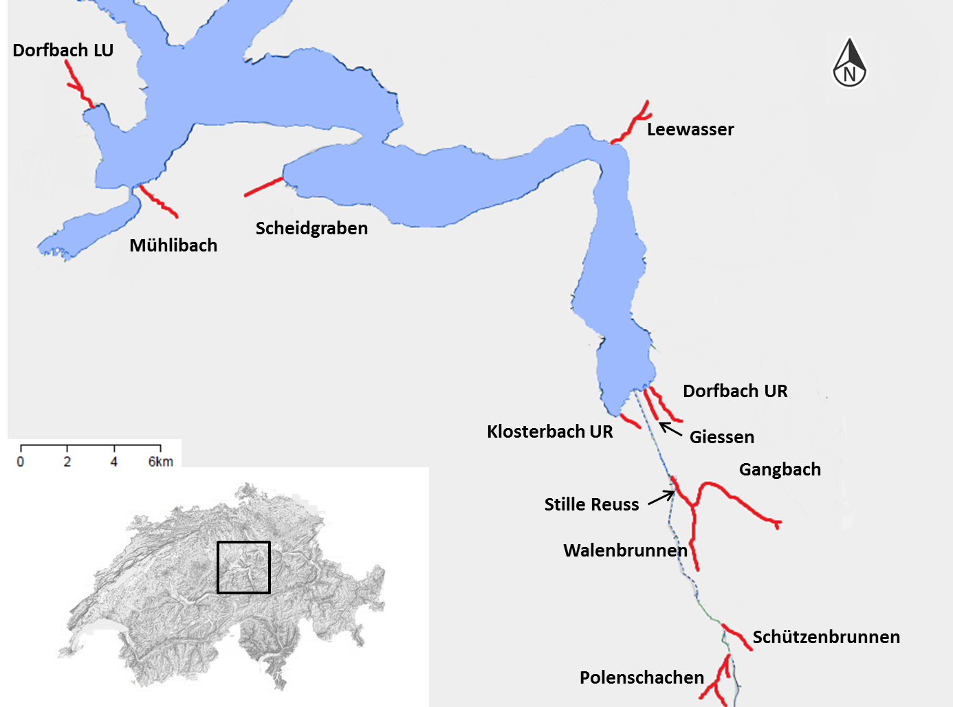

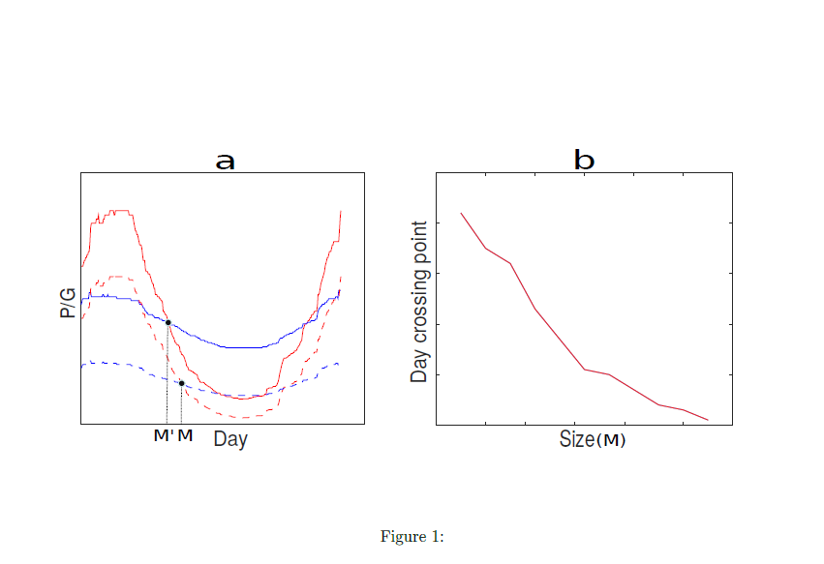

Figure 2

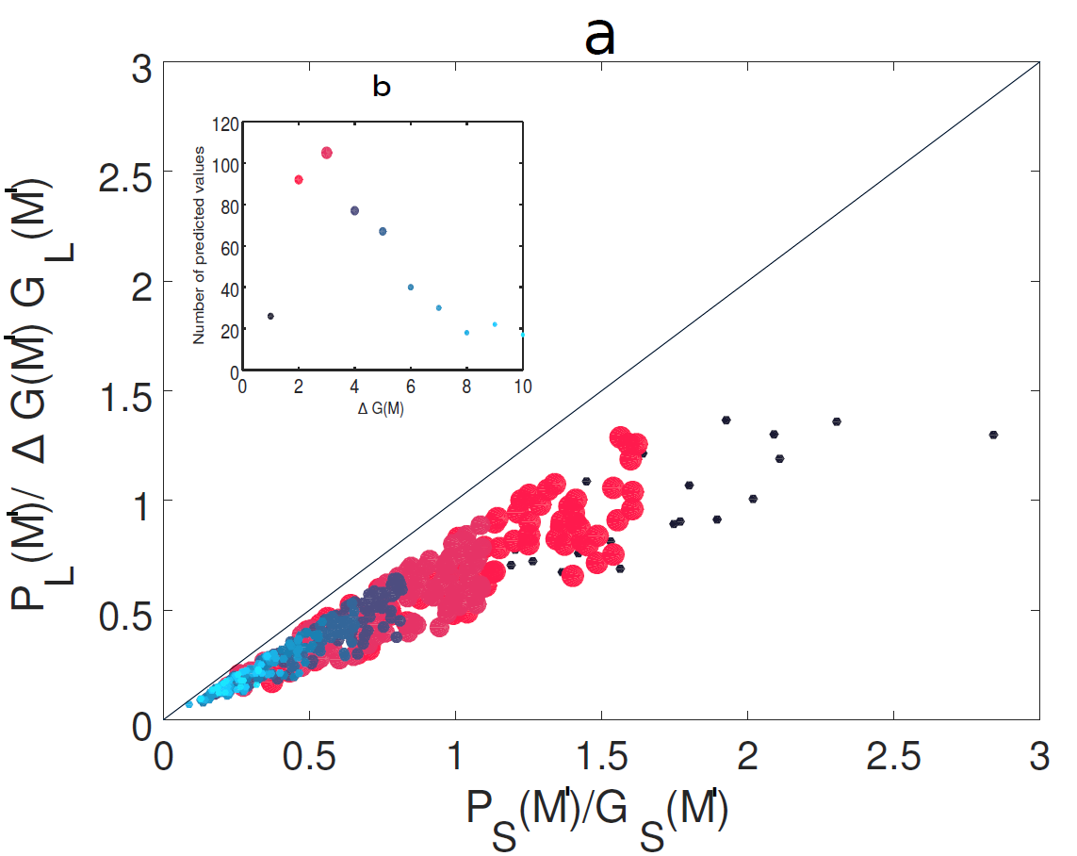

Figure 3

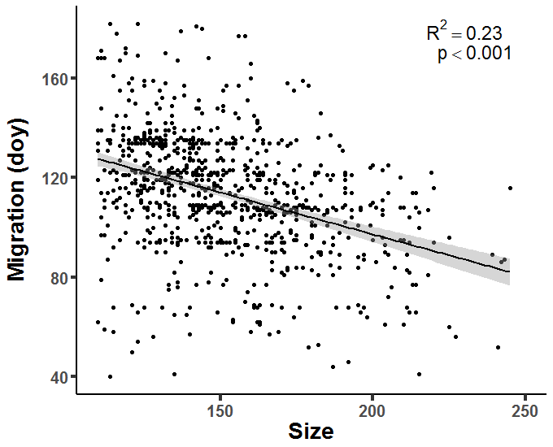

Figure 4

# Supplement

Table S1: Number of tagged fish and migrants by stream

|  |  |  |
| --- | --- | --- |
| **Stream** | **Fish tagged** | **Migrants** |
| Dorfbach LU | 179 | 19 |
| Dorfbach UR | 246 | 60 |
| Gangbach | 317 | 31 |
| Giessen | 288 | 121 |
| Klosterbach UR | 359 | 174 |
| Leewasser | 331 | 17 |
| Mühlibach | 458 | 31 |
| Polenschachen | 132 | 42 |
| Scheidgraben | 401 | 96 |
| Schützenbrunnen | 404 | 110 |
| Stille Reuss | 356 | 61 |
| Walenbrunnen | 341 | 62 |

Table S2: Immature lake trout captured during fall spawning fisheries

|  |  |  |  |
| --- | --- | --- | --- |
| **River** | **Date** | **Total length (mm)** | **Weight (g)** |
| Giessen | 17.11.2015 | 225 | 99.70 |
| Giessen | 13.11.2017 | 313 | 265.10 |
| Klosterbach UR | 15.11.2016 | 202 | 61.80 |
| Klosterbach UR | 13.12.2016 | 306 | 276.60 |
| Mühlibach | 24.11.2017 | 250 | 142.80 |
| Mühlibach | 24.11.2017 | 324 | 380.00 |
| Mühlibach | 07.12.2017 | 283 | 204.50 |
| Mühlibach | 07.12.2017 | 354 | 321.50 |
| Scheidgraben | 06.12.2016 | 289 | 241.30 |
| Scheidgraben | 06.12.2016 | 262 | 181.30 |